**Screenshots:**

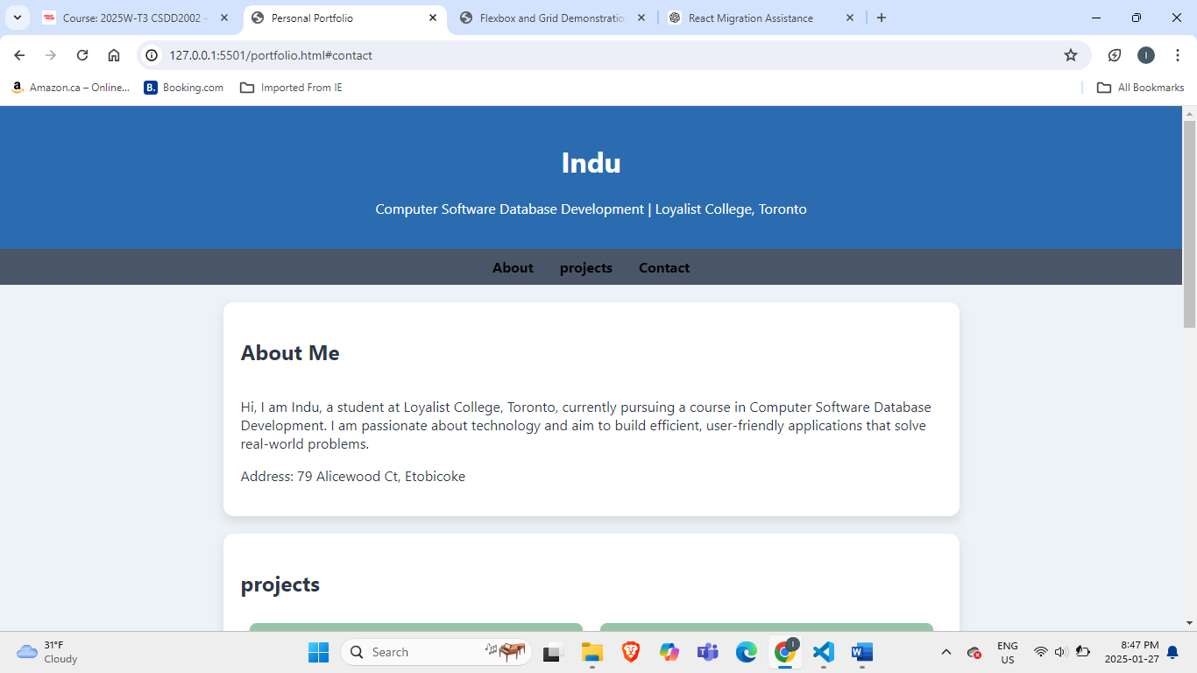

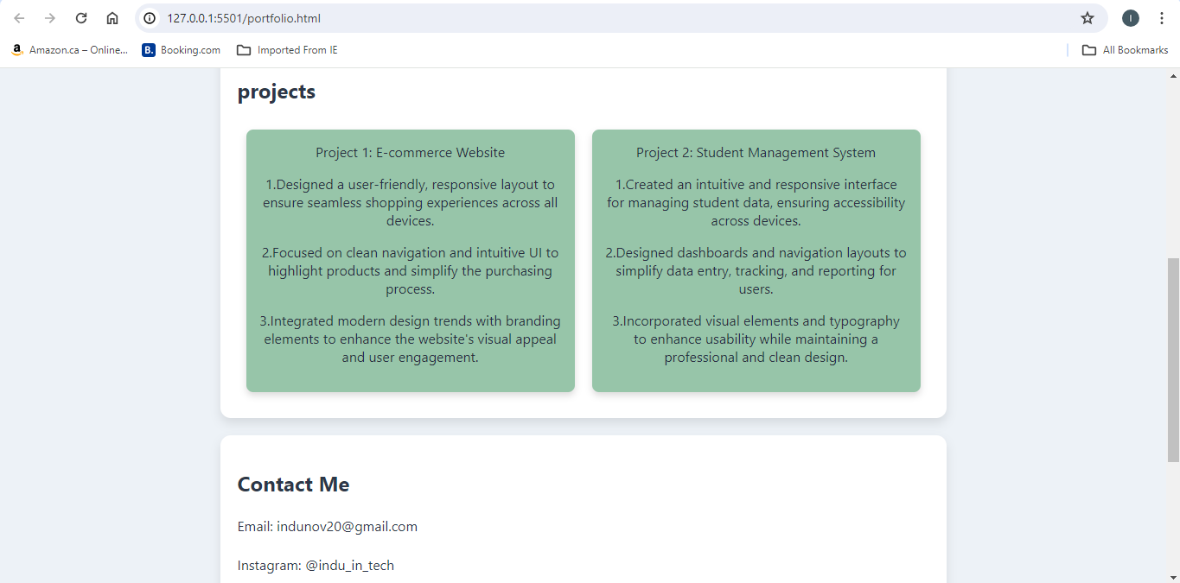

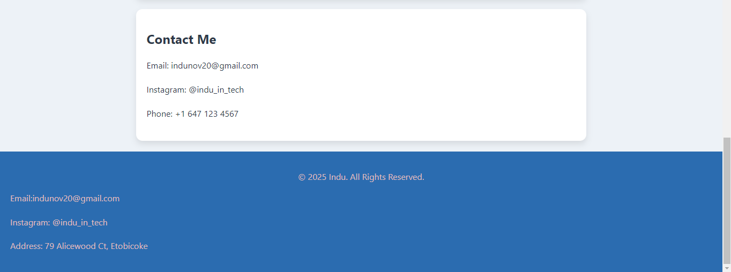

**Code**:

<!DOCTYPE html>

<html lang="en">

<head>

    <meta charset="UTF-8">

    <meta name="viewport" content="width=device-width, initial-scale=1.0">

    <title>Personal Portfolio</title>

    <style>

        body {

            font-family: 'Segoe UI', Tahoma, Geneva, Verdana, sans-serif;

            margin: 0;

            padding: 0;

            background-color: #edf2f7;

            color: #2d3748;

        }

        header {

            background-color: #2b6cb0;

            color: #ffffff;

            padding: 20px;

            text-align: center;

        }

        nav {

            display: flex;

            justify-content: center;

            background-color: #4a5568;

            padding: 10px;

        }

        nav a {

            color: #020507;

            text-decoration: none;

            margin: 0 15px;

            font-weight: bold;

        }

        nav a:hover {

            text-decoration: underline;

        }

        .about, .projects, .contact {

            padding: 20px;

            margin: 20px auto;

            max-width: 800px;

            background-color: #ffffff;

            border-radius: 12px;

            box-shadow: 0 6px 12px rgba(0, 0, 0, 0.1);

        }

        .projects-grid {

            display: grid;

            grid-template-columns: repeat(auto-fit, minmax(200px, 1fr));

            gap: 20px;

            padding: 10px;

        }

        .projects-item {

            background-color: #97c5a9;

            color: #272f41;

            text-align: center;

            padding: 15px;

            border-radius: 8px;

            box-shadow: 0 4px 8px rgba(22, 11, 11, 0.15);

        }

        footer {

            background-color: #2b6cb0;

            color: #e0bdbd;

            text-align: center;

            padding: 20px;

            margin-top: 20px;

        }

        .contact-info {

            text-align: left;

            line-height: 1.8;

            margin-top: 15px;

        }

    </style>

</head>

<body>

    <header>

        <h1>Indu</h1>

        <p>Computer Software Database Development | Loyalist College, Toronto</p>

    </header>

    <nav>

        <a href="#about">About</a>

        <a href="#projects">projects</a>

        <a href="#contact">Contact</a>

    </nav>

    <section id="about" class="about">

        <h2>About Me</h2>

        <div style="display: flex; align-items: center; gap: 20px;">

            <div>

                <p>

                    Hi, I am Indu, a student at Loyalist College, Toronto, currently pursuing a course in Computer Software Database Development. I am passionate about technology and aim to build efficient, user-friendly applications that solve real-world problems.

                </p>

                <p>Address: 79 Alicewood Ct, Etobicoke</p>

            </div>

        </div>

    </section>

    <section id="projects" class="projects">

        <h2>projects</h2>

        <div class="projects-grid">

            <div class="projects-item">Project 1: E-commerce Website

                <p>1.Designed a user-friendly, responsive layout to ensure seamless shopping experiences across all devices.</p>

                    <p>2.Focused on clean navigation and intuitive UI to highlight products and simplify the purchasing process.</p>

                    <p>3.Integrated modern design trends with branding elements to enhance the website's visual appeal and user engagement.</p>

            </div>

            <div class="projects-item">Project 2: Student Management System

                <p>1.Created an intuitive and responsive interface for managing student data, ensuring accessibility across devices.</p>

                <p>2.Designed dashboards and navigation layouts to simplify data entry, tracking, and reporting for users.</p>

                <p>3.Incorporated visual elements and typography to enhance usability while maintaining a professional and clean design.</p>

            </div>

        </div>

    </section>

    <section id="contact" class="contact">

        <h2>Contact Me</h2>

        <div class="contact-info">

            <p>Email: indunov20@gmail.com</p>

            <p>Instagram: @indu_in_tech</p>

            <p>Phone: +1 647 123 4567</p>

        </div>

    </section>

    <footer>

        <p>&copy; 2025 Indu. All Rights Reserved.</p>

        <div class="contact-info">

            <p>Email:indunov20@gmail.com</p>

            <p>Instagram: @indu_in_tech</p>

            <p>Address: 79 Alicewood Ct, Etobicoke</p>

        </div>

    </footer>

</body>

</html>